Long term memory

6.1 The nature and function of memory
6.2 The first memory experiments
6.3 Meaning, knowledge, and schemas
6.4 Input processing and encoding
6.5 Retrieval and retrieval cues
6.6 Memory systems
6.7 Retrieval practice and retrieval inhibition
6.8 Theories of forgetting
6.9 Memory in real-life settings
6.10 Eyewitness testimony

6.1 The nature and function of memory

LTM is important in everyday life since it enables us to store information and experiences in a lasting fashion, possible retrieval at any point in future. We can understand and deal with future situations
Processes of thinking of problem solving rely heavily on previous experiences

Memory process is divided to three main stages:
Input stage : Newly perceived information is being learned or encoded into memory
Storage stage: Information is held in preparation for some future occasion
Output stage : information is retrieved from storage

A memory trace will only be retrievable if all three of these stages are successfully completed
When we find we are Unable to recall some items because of a failure of one of these stages

6.2 The first memory experiments

Ebbinghaus used himself as the subject to study memory performance
A list of syllables were learned and re tested after a retention period, results were plotted on a forgetting curve
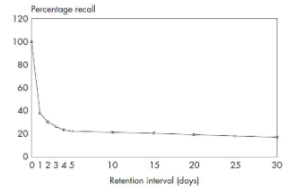

Autobiographical events of personal significance are remembered for longer periods and far more accurately

Ebbinghaus suggested two main theories for the forgetting curve :
Decay : Memories fade away with passage of time regardless of input
Interference : Memories are actively disrupted by influence of some other input

Evidence of interference :
Retro-active interference : Memory scores for the learning of one list was reduced by the learning of a second list
Pro-active interference : memory for a list was also subject to interfere from a previously learned list

Many studies showed that effects of interference largely depends on its similarity between target items and the item interfering with it.
Interference is considered the main cause of forgetting

Evidence for spontaneous decay :
Both decay and interference do appear to play a part in the forgetting process.
Decay with disuse : decay only affects memory traces remained unretrieved for a long period
New theory of disuse : access to a memory trace is strengthened by frequent retrieval.

6.3 Meaning, knowledge, and schemas
First experimental demonstration :
Starts with a native American folk tale of ghosts, participants tell the story as Chinese whispers, the story becomes distorted, however participants tend to rationalise the story to make it fit within expectation based on experience and knowledge

Bartlett explanation Schema theory :
We encode memories from past experiences. Schemas are mental representations that we have built up from all that we have experienced in the past. We compare any new perceptual input with out past schemas to find something meaningful and familiar, any input that does not match with existing schemas will be distorted to match or not retained at all
Can we rely on the accuracy of eyewitness testimony?
Many other studies confirmed that eyewitness testimony for a crime or incident can be distorted by previous knowledge and subsequent events
A passage is more memorable if we can use our own knowledge to increase its meaningfulness
Individuals who have a great deal of expert knowledge about a subject are particularly good at remembering material in that field

The human brain doesn’t appear to be well studied at rote learning (parrot learning)
Mnemonic is a technique or strategy used for improving the memorability of items by adding meaningful associations.
Mnemonics , their effectiveness is evidence that people are much better at memorising meaningful information which they are able to relate to their previous knowledge.

6.4 Input processing and encoding
Level of processing theory : Processing of new perceptual input involves the extraction of information at a series of levels of increasing depth of analysis, with more information extracted at each level
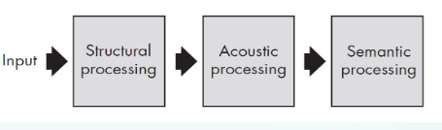
Crucial aspect of the level of processing theory, need to carry out extensive processing of incoming information in order to store it in the LTM
Repetition is not enough, it need actives processing of input
Memory trace is a by product of perceptual processing

Main prediction is that retention of a memory trace depends on the depth to which it has been processed during encoding stage
Explains why meaningful material is more memorable than non meaningful material
Example : same list of 60 words to three different groups of subjects, gave each group a different orienting task to carry out. Orienting tasks were given :
Structural orienting task : is word in block capitals
Acoustic orienting task : does word rhyme with bat
Semantic orienting task : Does word fit a sentence
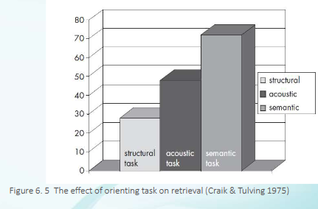

Craiks test of incidental learning rather than intentional learning
The results of the experiment confirmed that deeper processing creates a stronger memory trace, even if we are not trying to learn test items
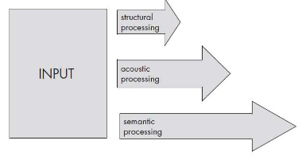
Semantic processing is more effective than non semantic processing.
Elaborative encoding – Formation of associative connections with other memory traces
Creates a large number of associative links with other items in the memory store so that new trace becomes incorporated into an extensive network of interconnected memory traces.
Mandler showed that retrieval was improved when test items were organised into categories by the participant. Memory is organised into a semantic network of related items, and accessing one item activated the whole network

6.6 Memory systems
In a recognition test, the original test material is presented again at retrieval stages
In a recall test there is no representation of material
In test of cued recall the participant is provided with retrieval cues which help to remind them of target items
In a test of spontaneous recall no cues are presented, so the participant is required to generate the target items without any assistance.
Spontaneous recall : requires the generation of items from memory without any help
Cued recall : retrieval cues are provided as a reminder of the items to be recalled
Recognition : original test items are presented again at retrieval stage

People can recognise far more items than they can recall. Average spontaneous recall score 38% and recognition score 96%

Generate and recognise (GR) theory : recall and recognition are different processes. Recall is more difficult because it involves an extra stage. In a recall test the participant must first generate possible target items, after generated are subjected to a recognition test to discriminate between correct and incorrect items
Recall has two stages, generate and recognise while recognition has only recognise
Important feature of thr GR theory : Recognition is one of the sub processes of recall. Prediction is when any items that can be recalled should also be recognisable
In certain situations people are unable to recognise items which they can recall.
This phenomenon is known as recognition failure of recallable items . Recognition failure is most easily demonstrated with a design in which strong retrieval cues are provided for recall but not for recognition.

